TABLEAU FINAL PROJECT 100 marks



**Part A:** Analyze the datasets and required output. **(75 Marks)**

1. Review the datasheets excel files. There were three sheets received. **Orders, People** and **Returns**.
2. **Orders data** has details of all sales, profit, orders, regions and products.
3. **People** sheet has names of sales person and their respective region.
4. **Return** sheet has those orders Ids which were returned.
5. ‘Region’ detail from **Orders** table can be mapped with ‘Region’ of **People** table to track sales person. You can connect those data bases based on region.
6. Similarly, ‘Order ID’ from **Orders** table can be mapped with ‘Order Id’ of **Return** table to track regional returned orders.
7. This information means that we can blend information from these tables to answer our question.
8. Load the excel files.
9. Create relationship as mentioned in above point 5 and 6. **(10 Marks**)
10. Formatting can be different, but content should be same.
11. Create visuals and dashboard with below output. Remove NULL values from map visual. **(25 Marks)**
12. After creating dashboard, make sure your visuals are interactive **(50 Marks)**
13. Follow video lectures to complete this project.

Output Dashboard

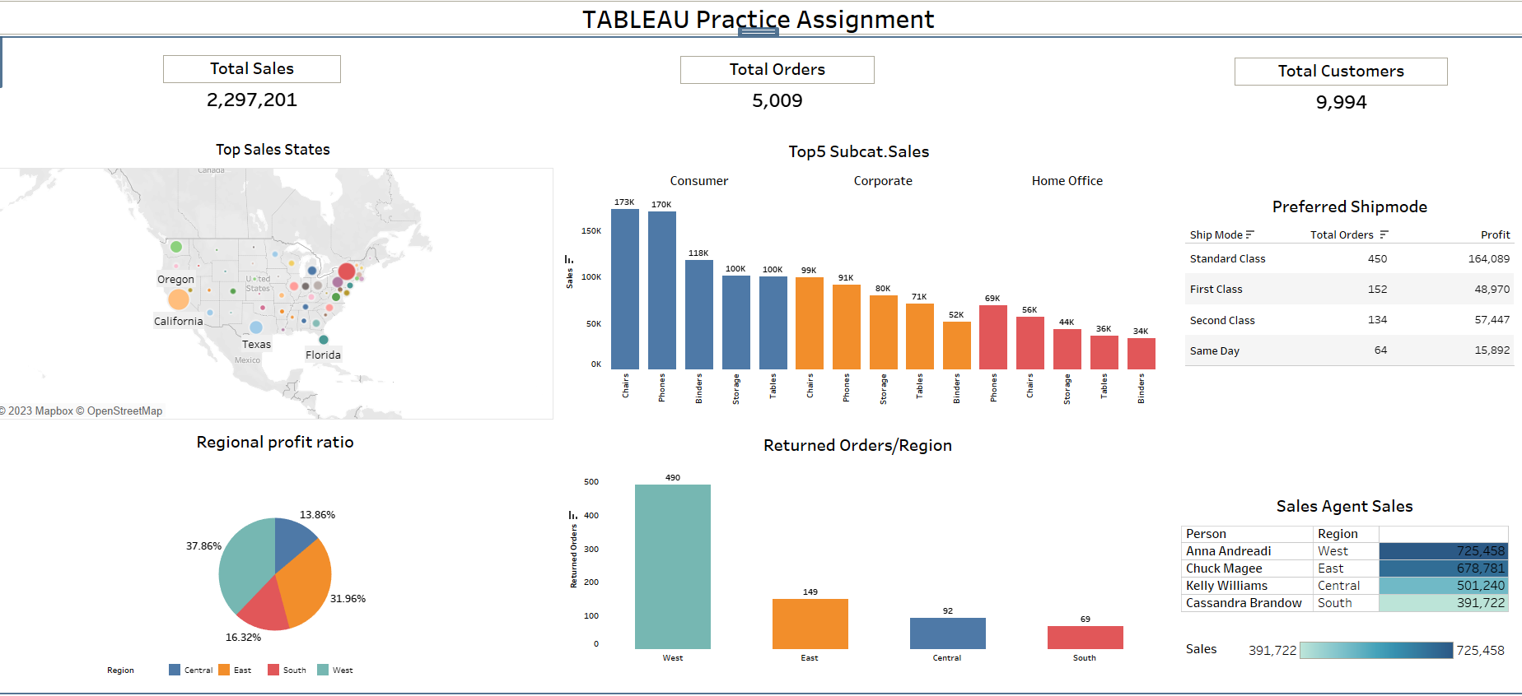

**Part B:** Using interactive visualization, answer below questions from your dashboard visuals. **(25 Marks)**

1. For **WEST** region, which state has highest sales?
2. How many unique **TOTAL ORDERS** received in **WEST** region?
3. In **SOUTH** region, which **SUB-CAT** has highest sales?
4. What are the **TOTAL SALES** of **sub-cat CHAIRS** in **CONSUMER** segment?
5. Which **SHIPPING MODE** has lowest **PROFIT** in **EAST** region?